Model Evaluation - Regression Performance

Visualizations of the model fit are critical to understanding if the model is fit for purpose.

The residual plot is particular useful.

# RMSE

When an outcome is a number, the most common method for characterizing the predictive capability is the root mean squared error.

The RMSE is interpreted as how far the residuals are from zero, or as the average distance between the observed and predicted values.

# RSquared

Another common metric is the coefficent of determination. Commonly written as R^2.

The value can be interpreted as the proportion of the information in the data that is explained by the model.

This an Rsquared of 0.75 implies that the model can explain three-quarters of the variation in the outcome.

While its an easily interpreted stat, the practioner must remember that R2 is a measure of correlation, not accuracy. And thus can be misleading where their is a non-linear relationship between outcome and prediction.

Also the metric is dependant on the variation in the outcome. Test sets with low variation will have a lower Rsquared.

# Rank Correlation

In some cases the goal of the model is to simply rank new samples.

E.G. as a part of screening studies.

In this case the metric is the correlation between the rank of the outcomes vs. the ranks of the predicted values.

This metric is commonly known as the Spearmans rank correltation.

# Computing

## Diagnostics plot

source("~/MCD/MCD/m.R")  
  
library(mlbench)  
data(PimaIndiansDiabetes)  
data(longley)  
  
m_longley <-  
 m_data(longley) %>%  
 m_response("Employed") %>%  
 m_linear_regression() %>%  
 m_cross_validation(number = 5) %>%  
 m_rmse_metric() %>%  
 m_train()

## [1] "longley"

m_diagnostics_plot(m_longley)

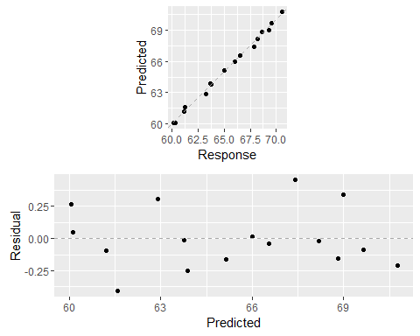

## Metric calculation

**RMSE**

m_get_RMSE(m_longley)

## [1] 0.2286406

**Rsquared**

m_get_R2(m_longley)

## [1] 0.995479

**Rank Correlation**

m_get_rank_correlation(m_longley)

## [1] 0.9941176